GUESS

WHO?

NAME :

ADDMISSION NO. :

CLASS :

ROLL NO. :

SUBJECT : COMPUTER SCIENCE(PYTHON)

SCHOOL : DELHI PUBLIC SCHOOL SURAT

ACADEMIC YEAR : 2020-21



**DELHI PUBLIC SCHOOL SURAT**

**Name of the Student** : ________________________________________

**Admission Number** : ________________________________________

**Board Roll Number** : ________________________________________

**Class & Section** : ________________________________________

**Subject** : ________________________________________

**Project Topic** : ________________________________________

**This is certified as the bonafide work of the student as per the  CBSE internal assessment guidelines for the academic year  2020-21.**

**Teacher In-charge Principal**

**External Examiner School Seal**

ACKNOWLEDGEMENT

I wish to take this opportunity to express my gratitude to all those who have extended their assistance in various ways during the making of this project work. I thank everyone for facilitating and encouraging me from time to time at all stages for the successful completion of this project.

I extend my sincere thanks to all my teachers who helped me with their invaluable supervision and suggestions during the development of this project.

I am grateful to the Principal and school management for providing me with all the necessary facilities and guidance at every step.

Lastly, I would like to thank my classmates and family members for extending their cooperation and support in all possible ways to complete this project work.

ABOUT THE GAME:

Guess who is an arcade game wherein a human plays against the computer.

There are a set of 22 characters,each having some different and some similar characteristics to each other.

The computer selects a character at random and the user have to guess who the character was by analysing the hints given by the computer!

**Isn’t it exciting?!**

EXTERNAL LIBRARIES USED IN THE CODE:

1.PYGAME :

* TO INITIATE THE DISPLAY
* CREATE BUTTON
* INPUT TEXT

PYGAME BUILT IN FUNCTIONS USED:

* pygame.image.load()
* pygame.transform.scale()
* win.blit()
* pygame.MOUSEBUTTONDOWN()
* pygame.display.update()
* win.fill((COLOR CODE))
* pygame.mouse.get_pos()
* font.render
* pygame.Rect()
* FONT.render()
* rect.collidepoint()
* pygame.K_BACKSPACE
* pygame.draw.rect()

2.TIME :

* TO MAKE THE PROGRAM WAIT FOR A PARTICULAR AMOUNT OF TIME

CODE:

import pygame, random,time

from pygame.locals import *

pygame.init()

#Defining characters charteristics

import mysql.connector as msql

mydb=msql.connect(

host="localhost",

user="root",

database="guesswho",

password="admin1234"

)

mycursor=mydb.cursor()

mycursor.execute("SHOW DATABASES")

for x in mycursor:

print(x)

character_list=[["andy","large eyebrows","black hair",'male','brown eyeballs','black','big lips'],

['ashley','female','wears cap/hat','white','small lips','brown eyeballs','reddish-brown hair'],

["brandon","blonde hair","wears cap/hat",'male','white','without beard','small lips','brown eyeballs'],

['chris','male','wears cap/hat','white','small lips','brown eyeballs','without beard','small lips'],

['connor','male','moustache','black','small lips','brown eyeballs','brown hair'],

['daniel','male','wears cap/hat','black','small lips','large eyebrows'],

['david','male','bald','white','beard','large eyebrows','brown eyeballs','small lips'],

['emily','female','spectacles','white','white hair','small lips','blue eyeballs'],

['jake','male','moustache','white','blonde hair','brown eyeballs','small lips'],

['james','brown eyeballs','bald','male','small lips','beard','black'],

['jon','white hair','small lips','white','male','beard'],

['joseph','blue eyeballs','spectacles','reddish-brown hair','white','male','small lips'],

['justin','moustache','white','small lips','brown eyeballs','male'],

['kyle','blonde hair','big lips','blue eyeballs','white','male'],

['matt','white','male','small lips','white hair'],

['megan','blonde hair','female','blue eyeballs','small lips','white'],

['nick','spectacles','white','male','small lips','blue eyeballs','bald'],

['rachael','wears cap/hat','small lips','white','female','brown hair'],

['sarah','black','black hair','big lips','wears spectacles','female','brown eyeballs'],

['tyler','moustache','big lips','brown eyeballs','black hair','large eyebrows','white','male'],

['william','white','male','blonde hair','small lips','brown eyeballs'],

['zachary','large eyebrows','brown eyeballs','small lips','white','male','bald'],

]

win=pygame.display.set_mode((1300,900))

win.fill((255,255,255))

#All functions

class button():

def __init__(self, color, x,y,width,height, text=''):

global w

w=width

global h

h=height

self.color = color

self.x = x

self.y = y

self.width = width

self.height = height

self.text = text

def draw(self,win,outline=None):

#Call this method to draw the button on the screen

if outline:

pygame.draw.rect(win, outline, (self.x-2,self.y-2,self.width+4,self.height+4),0)

#pygame.draw.rect(win, outline, (self.x,self.y,self.width,self.height),0)

pygame.draw.rect(win, self.color, (self.x,self.y,self.width,self.height),0)

if self.text != '':

font = pygame.font.SysFont('comicsansms', 20)

text = font.render(self.text, 1, (0,0,0))

win.blit(text, (self.x + (self.width/2 - text.get_width()/2), self.y + (self.height/2 - text.get_height()/2)))

def isOver(self, pos):

#Pos is the mouse position or a tuple of (x,y) coordinates

if pos[0] > self.x and pos[0] < self.x + self.width:

if pos[1] > self.y and pos[1] < self.y + self.height:

return True

return False

#Text box functions

import pygame

pygame.init()

COLOR_INACTIVE = pygame.Color('lightskyblue3')

COLOR_ACTIVE = pygame.Color('dodgerblue2')

FONT = pygame.font.Font(None, 38)

class InputBox:

def __init__(self, x, y, w, h, text=''):

self.rect = pygame.Rect(x, y, w, h)

self.color = COLOR_INACTIVE

self.text = text

self.txt_surface = FONT.render(text, True, self.color)

self.active = False

def handle_event(self, event):

if event.type == pygame.MOUSEBUTTONDOWN:

# If the user clicked on the input_box rect.

if self.rect.collidepoint(event.pos):

# Toggle the active variable.

self.active = not self.active

else:

self.active = False

# Change the current color of the input box.

self.color = COLOR_ACTIVE if self.active else COLOR_INACTIVE

if event.type == pygame.KEYDOWN:

if self.active:

if event.key == pygame.K_RETURN:

#print(self.text)

global text_ans

text_ans=self.text

if(self.text!=""):

print(self.text)

return

self.text = ''

#print (a)

#pygame.quit()

elif event.key == pygame.K_BACKSPACE:

self.text = self.text[:-1]

else:

self.text += event.unicode

# Re-render the text.

self.txt_surface = FONT.render(self.text, True, self.color)

def update(self):

# Resize the box if the text is too long.

width = max(200, self.txt_surface.get_width()+10)

self.rect.w = width

def draw(self, screen):

# Blit the text.

screen.blit(self.txt_surface, (self.rect.x+5, self.rect.y+5))

# Blit the rect.

pygame.draw.rect(screen, self.color, self.rect, 2)

def blackout(c_req,ans,character_list,size_list,t_x,t_y):

adnum=0

for i in character_list:

if i[0]==ans:

c_number=adnum

break

adnum+=1

if(c_req in character_list[c_number]):

for i in range(0,22):

if(character_list[i][0]==ans):

continue

elif c_req not in character_list[i]:

namei=character_list[i][0]

#print("going")

for k in size_list:

if ((k[0]==namei) and (k[0] not in check_list)) :

check_list.append(k[0])

wimage = pygame.image.load(r'C:\Users\ADMIN\Desktop\Guess who\WR.png')

wimage = pygame.transform.scale(wimage, (80,70))

win.blit(wimage, (k[1]+20,k[2]+30))

pygame.display.update()

textwrite(c_req+' : YES',(0, 0, 128),30,t_x,t_y)

elif(c_req not in character_list[c_number]):

#print("2")

for i in range(0,22):

if(character_list[i][0]==ans):

continue

elif c_req in character_list[i]:

namei=character_list[i][0]

#print("going")

for k in size_list:

if ((k[0]==namei) and (k[0] not in check_list)) :

check_list.append(k[0])

wimage = pygame.image.load(r'C:\Users\ADMIN\Desktop\Guess who\WR.png')

wimage = pygame.transform.scale(wimage, (80,70))

#pygame.display.update()

#print("This:",k[1],k[2])

win.blit(wimage, (k[1]+20,k[2]+30))

pygame.display.update()

textwrite(c_req+' : NO',(0, 0, 128),30,t_x,t_y)

input_box1 = InputBox(500, 400, 250, 40)

def textwrite(you_said,cl,f_size,x_co,y_co):

font = pygame.font.Font('freesansbold.ttf', f_size)

texti = font.render(you_said, True, cl)

textRect = texti.get_rect()

textRect.center = (x_co,y_co)

win.blit(texti, textRect)

def up_score(n,s):

cursor = mydb.cursor

sql="""INSERT INTO gs VALUES(%s,%s)"""

val=[(n,s)]

mycursor.executemany(sql,val)

mydb.commit()

cursor = mydb.cursor(dictionary=True)

mycursor.execute("SELECT * FROM GS")

myresult=mycursor.fetchall()

for X in myresult:

print(X)

return

def down_score():

cursor = mydb.cursor

cursor = mydb.cursor(dictionary=True)

mycursor.execute("SELECT * FROM GS")

myresult=mycursor.fetchall()

cp=[]

cp_max5=[]

cpd=[]

cpr=[]

not_again=1

for X in myresult:

print(X)

d1=X[0]

d2=X[1]

cp.append(d1)

d2=d2+not_again

cpd.append(d2)

cp_max5.append(d2)

cpr.append([d2,not_again])

not_again+=1

print(cpr)

cp_max5.sort()

cp_max5=cp_max5[::-1]

#cpr.sort()

print(cpr)

print(cpd)

print(cp_max5)

x1=250

x2=620

y1=375

y2=375

for i in range(0,5):

g=cp_max5[i]

for i in range(0,len(cpr)):

if(cpr[i][0]==g):

j=cpr[i][1]

break

print(g)

ind=cpd.index(g)

h=cp[ind]

g=g-j

textwrite(h,(0,0,0),20,x1,y1)

textwrite(str(g),(0,0,0),20,x2,y2)

y1+=65

y2+=65

pygame.display.update()

run=True

wimage = pygame.image.load(r'C:\Users\ADMIN\Desktop\Guess who\WR.png')

play_again=1

while run==True:

#redrawWindow()

#pygame.display.update()

if(play_again==1):

cursor = mydb.cursor(dictionary=True)

mycursor.execute("SELECT * FROM GS")

myresult=mycursor.fetchall()

mydb.commit()

sql_list=[]

sql_list_score=[]

for X in myresult:

sql_list.append(X[0])

sql_list_score.append(X[1])

name_list=[]

for i in character_list:

name_list.append(i[0])

Not_needed_in_button=[['male','female'],['big lips','small lips'],['white','black']]

ans_no=random.randint(0,len(character_list)-1)

ans=character_list[ans_no][0]

Possible_Qlist=["black","blonde hair","male","female","large eyebrows","wears cap/hat",

'small lips','spectacles','blue eyeballs','moustache','bald','big lips','white']

up_Qlist=Possible_Qlist

print(ans)

score=0

text_ans=""

stpage=False

win.fill((255,255,255))

stp1 = pygame.image.load(r'C:\Users\ADMIN\Desktop\Guess who\BK.png')

stp1 = pygame.transform.scale(stp1, (1350,850))

win.blit(stp1, (0,0))

pygame.display.update()

#time.sleep(5)

stp1Button=button((0,255,0),1100,700,100,50,'Skip')

stp1Button.draw(win,(0,0,0))

pygame.display.update()

dis=True

while(dis==True):

for event in pygame.event.get():

pos=pygame.mouse.get_pos()

if 1100+100 > pos[0] > 1100 and 700+50 > pos[1] > 700:

if event.type==pygame.MOUSEBUTTONDOWN:

dis=False

stpage=True

break

win.fill((255,255,0))

stp = pygame.image.load(r'C:\Users\ADMIN\Desktop\Guess who\HWT.png')

stp = pygame.transform.scale(stp, (900,600))

win.blit(stp, (150,100))

stpButton=button((0,255,0),1100,700,100,50,'Skip')

stpButton.draw(win,(0,0,0))

pygame.display.update()

while(stpage==True):

for event in pygame.event.get():

pos=pygame.mouse.get_pos()

if 1100+100 > pos[0] > 1100 and 700+50 > pos[1] > 700:

if event.type==pygame.MOUSEBUTTONDOWN:

done=False

stpage=False

break

while not done:

for event in pygame.event.get():

input_box1.handle_event(event)

win.fill((255,255,51))

textwrite("Hey,Enter a Username",(0, 0, 128),40,600,200)

input_box1.draw(win)

pygame.display.flip()

if(text_ans==""):

done=False

else:

username_sql=text_ans

pygame.display.update()

break

sql_ask=0

sql_sc=0

if(username_sql in sql_list):

sql_ask=1

keep=sql_list.index(username_sql)

sql_sc=sql_list_score[keep]

cursor = mydb.cursor(dictionary=True)

sql="""delete from gs where Username='%s'"""%(username_sql)

mycursor.execute(sql)

mydb.commit()

win.fill((59,236,177))

textwrite("Welcome Back !!",(0,0,0),70,450,400)

pygame.display.update()

time.sleep(4)

else:

win.fill((59,236,177))

textwrite("Welcome New user!!",(0,0,0),70,450,400)

pygame.display.update()

time.sleep(4)

win.fill((156,102,31))

textwrite("Example: ",(0,0,0),30,950,100)

example_image = pygame.image.load(r'C:\Users\ADMIN\Desktop\Guess who\Pics\c_nick.jpg')

example_image = pygame.transform.scale(example_image, (120,140))

win.blit(example_image, (880,200))

textwrite(">Bald",(0,0,0),20,1070,210)

textwrite(">Wears spectacles",(0,0,0),20,1135,240)

textwrite(">Blue eyeballs",(0,0,0),20,1115,270)

textwrite(">Small lips",(0,0,0),20,1100,300)

textwrite("ALL THE BEST!!",(0,0,0),60,300,300)

greenButton=button((0,255,0),1100,680,100,50,'Start')

greenButton.draw(win,(0,0,0))

pygame.display.update()

play_again=0

print("Out")

for event in pygame.event.get():

pos=pygame.mouse.get_pos()

if 1100+w > pos[0] > 1100 and 680+h > pos[1] > 680 and play_again==0:

if event.type==pygame.MOUSEBUTTONDOWN:

print("CLicked the button")

#win.fill((156,102,31))

blackout_list=[]

life=3

print(ans)

fun=""

crip=0

y=0

to_sc1=0

size_list=[]

check_list=[] #for function so no character gets wrong sign 2 times

to_sc1=1

xc=50

yc=50

win.fill((156,102,31))

for i in character_list:

if(xc>900):

xc=50

yc+=200

carImg = pygame.image.load(r'C:\Users\ADMIN\Desktop\Guess who\Pics\c_'+i[0]+'.jpg')

carImg = pygame.transform.scale(carImg, (120,140))

pik=[i[0],xc,yc]

size_list.append(pik)

win.blit(carImg, (xc,yc))

xc+=150

k=[]

#Working

nlist=Possible_Qlist

pygame.display.update()

# Not_needed_in_button=[['male','female'],['big lips','small lips'],['white','black']]

textwrite("Does he/she (HAVE/IS)",(0, 0, 128),20,1100,50)

Not_needed_in_button_recover=[]

print("C")

if(to_sc1==1):

print("Ci")

currentlength_list=len(nlist)-1

a1=random.randint(0,currentlength_list)

question_a1=nlist[a1]

k.append(nlist[a1])

nlist.remove(nlist[a1])

QButton=button((0,255,0),1100,100,140,50,question_a1)

QButton.draw(win,(0,0,0))

for i in Not_needed_in_button:

if (question_a1==i[0]):

print(i[1])

nlist.remove(i[1])

Not_needed_in_button_recover.append(i[1])

elif(question_a1==i[1]):

print(i[0])

nlist.remove(i[0])

Not_needed_in_button_recover.append(i[0])

currentlength_list=len(nlist)-1

a2=random.randint(0,currentlength_list)

question_a2=nlist[a2]

k.append(nlist[a2])

nlist.remove(nlist[a2])

QButton=button((0,255,0),1100,200,140,50,question_a2)

QButton.draw(win,(0,0,0))

for i in Not_needed_in_button:

if (question_a2==i[0]):

print(i[1])

nlist.remove(i[1])

Not_needed_in_button_recover.append(i[1])

elif(question_a2==i[1]):

print(i[0])

nlist.remove(i[0])

Not_needed_in_button_recover.append(i[0])

currentlength_list=len(nlist)-1

a3=random.randint(0,currentlength_list)

question_a3=nlist[a3]

k.append(nlist[a3])

nlist.remove(nlist[a3])

QButton=button((0,255,0),1100,300,140,50,question_a3)

QButton.draw(win,(0,0,0))

for i in Not_needed_in_button:

if (question_a3==i[0]):

print(i[1])

nlist.remove(i[1])

Not_needed_in_button_recover.append(i[1])

elif(question_a3==i[1]):

print(i[0])

nlist.remove(i[0])

Not_needed_in_button_recover.append(i[0])

prun=True

print("Cthr")

print(k)

pygame.display.update()

nor=[]

nor=k

while prun==True:

for event in pygame.event.get():

posi=pygame.mouse.get_pos()

if 1100+100 > posi[0] > 1100 and 100+50 > posi[1] > 100:

if event.type==pygame.MOUSEBUTTONDOWN:

us_ans=0

prun=False

#pos=pygame.mouse.get_pos()

elif 1100+200 > posi[0] > 1100 and 200+50 > posi[1] > 200:

if event.type==pygame.MOUSEBUTTONDOWN:

us_ans=1

prun=False

elif 1100+300 > posi[0] > 1100 and 300+50 > posi[1] > 300:

if event.type==pygame.MOUSEBUTTONDOWN:

us_ans=2

prun=False

print(nlist)

#nlist=["black","blonde hair","male","female","large eyebrows","wears cap/hat",

# 'small lips','spectacles','blue eyeballs','moustache','bald','big lips']

print(nlist)

#nlist.remove()

fun=nor[us_ans]

print(fun)

for i in Not_needed_in_button:

if((fun in k)):

print("i")

k.remove(fun)

if((i[0] in k) and i[0]!=fun):

print("i")

nlist.append(i[0])

nlist.append(i[1])

k.remove(i[0])

if((i[1] in k) and i[1]!=fun):

print("i")

nlist.append(i[0])

nlist.append(i[1])

k.remove(i[1])

for i in k:

nlist.append(i)

k.remove(i)

c_req=fun

print(nlist)

print("DOing..")

temp_list=nlist

blackout(c_req,ans,character_list,size_list,1100,370)

print("DOne")

# Second time

Not_needed_in_button_recover=[]

Not_needed_in_button=[['male','female'],['big lips','small lips'],['white','black']]

pin=[]

for i in nlist:

pin.append(i)

#print(nlist)

print(temp_list)

#temp_list=nlist

k=[]

nor=[]

pygame.display.update()

currentlength_list=len(temp_list)-1

a1=random.randint(0,currentlength_list)

question_a1=temp_list[a1]

k.append(temp_list[a1])

temp_list.remove(temp_list[a1])

QButton=button((0,255,0),1100,100,150,50,question_a1)

QButton.draw(win,(0,0,0))

print(temp_list)

for i in Not_needed_in_button:

if (question_a1==i[0]):

print(i[1])

temp_list.remove(i[1])

Not_needed_in_button_recover.append(i[1])

elif(question_a1==i[1]):

print(i[0])

temp_list.remove(i[0])

Not_needed_in_button_recover.append(i[0])

currentlength_list=len(temp_list)-1

a2=random.randint(0,currentlength_list)

question_a2=temp_list[a2]

k.append(temp_list[a2])

temp_list.remove(temp_list[a2])

QButton=button((0,255,0),1100,200,150,50,question_a2)

QButton.draw(win,(0,0,0))

print(temp_list)

for i in Not_needed_in_button:

if (question_a2==i[0]):

print(i[1])

temp_list.remove(i[1])

Not_needed_in_button_recover.append(i[1])

elif(question_a2==i[1]):

print(i[0])

temp_list.remove(i[0])

Not_needed_in_button_recover.append(i[0])

currentlength_list=len(temp_list)-1

a3=random.randint(0,currentlength_list)

question_a3=temp_list[a3]

k.append(temp_list[a3])

temp_list.remove(temp_list[a3])

QButton=button((0,255,0),1100,300,150,50,question_a3)

QButton.draw(win,(0,0,0))

pygame.display.update()

print(temp_list)

for i in Not_needed_in_button:

if (question_a3==i[0]):

print(i[1])

temp_list.remove(i[1])

Not_needed_in_button_recover.append(i[1])

elif(question_a3==i[1]):

print(i[0])

temp_list.remove(i[0])

Not_needed_in_button_recover.append(i[0])

prun=True

nor=k

while prun==True:

#print("Cthrough")

for event in pygame.event.get():

pygame.display.update()

posi=pygame.mouse.get_pos()

#if event.type==pygame.MOUSEBUTTONDOWN:

if 1100+100 > posi[0] > 1100 and 100+50 > posi[1] > 100:

if event.type==pygame.MOUSEBUTTONDOWN:

us_ans2=0

prun=False

#pos=pygame.mouse.get_pos()

elif 1100+200 > posi[0] > 1100 and 200+50 > posi[1] > 200:

if event.type==pygame.MOUSEBUTTONDOWN:

us_ans2=1

prun=False

#pos=pygame.mouse.get_pos()

elif 1100+300 > posi[0] > 1100 and 300+50 > posi[1] > 300:

if event.type==pygame.MOUSEBUTTONDOWN:

us_ans2=2

prun=False

print(k)

#temp_list=nlist

print(temp_list)

print(pin)

funs=nor[us_ans2]

print(funs)

for i in Not_needed_in_button:

if((funs in k)):

k.remove(funs)

if((i[0] in k) and i[0]!=funs):

temp_list.append(i[0])

temp_list.append(i[1])

k.remove(i[0])

if((i[1] in k) and i[1]!=funs):

temp_list.append(i[0])

temp_list.append(i[1])

k.remove(i[1])

for i in k:

print("Yes")

temp_list.append(i)

k.remove(i)

c_req=funs

#print(pin)

print("DOing..")

blackout(c_req,ans,character_list,size_list,1100,410)

print("DOne")

print(temp_list)

# Third Time

Not_needed_in_button=[['male','female'],['big lips','small lips'],['white','black']]

pin1=[]

for i in pin:

pin1.append(i)

Not_needed_in_button_recover=[]

k=[]

nor=[]

pygame.display.update()

currentlength_list=len(temp_list)-1

a1=random.randint(0,currentlength_list)

question_a1=temp_list[a1]

k.append(temp_list[a1])

temp_list.remove(temp_list[a1])

QButton=button((0,255,0),1100,100,150,50,question_a1)

QButton.draw(win,(0,0,0))

print(temp_list)

for i in Not_needed_in_button:

if (question_a1==i[0]):

print(i[1])

temp_list.remove(i[1])

Not_needed_in_button_recover.append(i[1])

elif(question_a1==i[1]):

print(i[0])

temp_list.remove(i[0])

Not_needed_in_button_recover.append(i[0])

currentlength_list=len(temp_list)-1

a2=random.randint(0,currentlength_list)

question_a2=temp_list[a2]

k.append(temp_list[a2])

temp_list.remove(temp_list[a2])

QButton=button((0,255,0),1100,200,150,50,question_a2)

QButton.draw(win,(0,0,0))

print(temp_list)

for i in Not_needed_in_button:

if (question_a2==i[0]):

print(i[1])

temp_list.remove(i[1])

Not_needed_in_button_recover.append(i[1])

elif(question_a2==i[1]):

print(i[0])

temp_list.remove(i[0])

Not_needed_in_button_recover.append(i[0])

currentlength_list=len(temp_list)-1

a3=random.randint(0,currentlength_list)

question_a3=temp_list[a3]

k.append(temp_list[a3])

temp_list.remove(temp_list[a3])

QButton=button((0,255,0),1100,300,150,50,question_a3)

QButton.draw(win,(0,0,0))

print(temp_list)

for i in Not_needed_in_button:

if (question_a3==i[0]):

print(i[1])

temp_list.remove(i[1])

Not_needed_in_button_recover.append(i[1])

elif(question_a3==i[1]):

print(i[0])

temp_list.remove(i[0])

Not_needed_in_button_recover.append(i[0])

pygame.display.update()

prun=True

nor=k

while prun==True:

#print("Cthrough")

pygame.display.update()

for event in pygame.event.get():

posi=pygame.mouse.get_pos()

#if event.type==pygame.MOUSEBUTTONDOWN:

if 1100+100 > posi[0] > 1100 and 100+50 > posi[1] > 100:

if event.type==pygame.MOUSEBUTTONDOWN:

us_ans3=0

prun=False

#pos=pygame.mouse.get_pos()

elif 1100+200 > posi[0] > 1100 and 200+50 > posi[1] > 200:

if event.type==pygame.MOUSEBUTTONDOWN:

us_ans3=1

prun=False

#pos=pygame.mouse.get_pos()

elif 1100+300 > posi[0] > 1100 and 300+50 > posi[1] > 300:

if event.type==pygame.MOUSEBUTTONDOWN:

us_ans3=2

prun=False

print(k)

#temp_list=nlist

print(temp_list)

print(pin1)

funs=nor[us_ans3]

print(funs)

for i in Not_needed_in_button:

if((funs in k)):

if((i[0]==funs or i[1]==funs)):

k.remove(funs)

if((i[0] in k) and i[0]!=funs):

temp_list.append(i[0])

temp_list.remove(i[0])

if((i[1] in k) and i[1]!=funs):

temp_list.append(i[0])

temp_list.append(i[1])

k.remove(i[1])

print(k)

for i in k:

print("Yes")

temp_list.append(i)

k.remove(i)

c_req=funs

print("DOing..")

blackout(c_req,ans,character_list,size_list,1100,450)

print("DOne")

# Now making a guess

guessButton=button((0,255,0),1100,570,100,50,'Guess')

guessButton.draw(win,(0,0,0))

pygame.display.update()

print(check_list)

if(sql_ask==1):

print("jaks")

score=sql_sc

else:

score=0

again=False

#check_list.remove(ans)

defender=22-len(check_list)

if(defender!=1):

while again==False:

for event in pygame.event.get():

pos=pygame.mouse.get_pos()

if 1100+100 > pos[0] > 1100 and 570+50 > pos[1] > 570:

if event.type==pygame.MOUSEBUTTONDOWN:

print("CLicked the button")

print("Time to guess")

remaining_c=21-len(check_list)

alt=remaining_c

win.fill((255,255,255))

print(check_list)

#king=False

if(alt==0):

time.sleep(4)

win.fill((255,255,255))

score+=100

want="Score: "+str(score)

print("You Win")

sButton=button((255,0,0),1050,100,200,50,want)

sButton.draw(win,(0,0,0))

up_score(username_sql,score)

#pygame.display.update()

leader_board = pygame.image.load(r'C:\Users\ADMIN\Desktop\Guess who\LB1.png')

leader_board = pygame.transform.scale(leader_board, (900,700))

win.blit(leader_board, (50,50))

textwrite("You Won",(0, 0, 128),30,1150,60)

pygame.display.update()

down_score()

print("Gaya")

time.sleep(7)

again=True

king=True

print("You Win")

#break

else:

king=False

while king==False:

for i in range(0,alt):

input_box2 = InputBox(1050, 400, 200, 40)

stay=0

text_ans=""

done=False

while done==False:

for event in pygame.event.get():

input_box2.handle_event(event)

win.fill((0,255,0))

textwrite("Your Guess:(in lowercase)",(0, 0, 0),20,1060,350)

#stay+=1

input_box2.draw(win)

pygame.display.update()

if(text_ans!=""):

done=True

else:

nameis=text_ans

#print("going")

for k in size_list:

if ((k[0]==nameis) and (k[0] not in check_list)) :

check_list.append(k[0])

wimage = pygame.image.load(r'C:\Users\ADMIN\Desktop\Guess who\WR.png')

wimage = pygame.transform.scale(wimage, (80,70))

win.blit(wimage, (k[1]+20,k[2]+30))

xc=50

yc=50

for i in character_list:

if(xc>900):

xc=50

yc+=200

carImg = pygame.image.load(r'C:\Users\ADMIN\Desktop\Guess who\Pics\c_'+i[0]+'.jpg')

carImg = pygame.transform.scale(carImg, (120,140))

win.blit(carImg, (xc,yc))

xc+=150

for k in size_list:

if(k[0] in check_list):

wimage = pygame.image.load(r'C:\Users\ADMIN\Desktop\Guess who\WR.png')

wimage = pygame.transform.scale(wimage, (80,70))

win.blit(wimage, (k[1]+20,k[2]+30))

if(nameis not in name_list):

print("Fooled")

#done=True

#time.sleep(2)

pygame.display.update()

if(nameis==ans):

score+=100

want="Score: "+str(score)

print("You Win")

sButton=button((255,0,0),1050,100,200,50,want)

sButton.draw(win,(0,0,0))

up_score(username_sql,score)

pygame.display.update()

time.sleep(4)

win.fill((255,255,255))

#pygame.display.update()

leader_board = pygame.image.load(r'C:\Users\ADMIN\Desktop\Guess who\LB1.png')

leader_board = pygame.transform.scale(leader_board, (900,700))

win.blit(leader_board, (50,50))

textwrite("You Won",(0, 0, 128),30,1150,60)

down_score()

pygame.display.update()

print("Gaya")

time.sleep(7)

print("KK")

king=True

again=True

break

else:

score-=20

want="Score: "+str(score)

print(want)

sButton=button((255,0,0),1050,100,200,50,want)

sButton.draw(win,(0,0,0))

textwrite("Wrong Guess!",(0, 0, 0),30,1100,600)

pygame.display.update()

print("yes")

time.sleep(4)

else:

up_score(username_sql,score)

win.fill((255,255,255))

leader_board = pygame.image.load(r'C:\Users\ADMIN\Desktop\Guess who\LB1.png')

leader_board = pygame.transform.scale(leader_board, (900,700))

print("Gaya")

win.blit(leader_board, (50,50))

textwrite("Sorry,You lose!!",(0, 0, 128),30,1150,60)

down_score()

pygame.display.update()

time.sleep(8)

king=True

again=True

else:

up_score(username_sql,100)

win.fill((255,255,255))

pygame.display.update()

#pygame.display.update()

leader_board = pygame.image.load(r'C:\Users\ADMIN\Desktop\Guess who\LB1.png')

leader_board = pygame.transform.scale(leader_board, (900,700))

win.blit(leader_board, (50,50))

textwrite("You Won",(0, 0, 128),30,1150,60)

pygame.display.update()

down_score()

print("Gaya")

time.sleep(7)

#funct algorithm

pygame.display.update()

win.fill((255,255,255))

textwrite("DO YOU WANT TO SAVE THE USERNAME?",(0, 0, 128),30,550,400)

fButton=button((255,0,0),1050,100,200,50,"Yes")

fButton.draw(win,(0,0,0))

fButton=button((255,0,0),1050,400,200,50,"No")

fButton.draw(win,(0,0,0))

pygame.display.update()

pri=True

while pri==True:

print("inw")

pygame.display.update()

for event in pygame.event.get():

pos=pygame.mouse.get_pos()

if 1050+200 > pos[0] > 1050 and 100+50 > pos[1] > 100:

if event.type==pygame.MOUSEBUTTONDOWN:

bon=1

pri=False

elif 1050+200 > pos[0] > 1050 and 400+50 > pos[1] > 400:

if event.type==pygame.MOUSEBUTTONDOWN:

bon=0

pri=False

else:

if(bon==1):

d=1

elif(bon==0):

cursor = mydb.cursor()

sql="""delete from gs where Username='%s'"""%(username_sql)

mycursor.execute(sql)

mydb.commit()

#prik=True

pygame.display.update()

win.fill((255,255,255))

textwrite("DO YOU WANT TO CONTINUE?",(0, 0, 128),30,550,400)

fButton=button((255,0,0),1050,100,200,50,"Yes")

fButton.draw(win,(0,0,0))

fButton=button((255,0,0),1050,400,200,50,"No")

fButton.draw(win,(0,0,0))

pygame.display.update()

#prik=True

prik=True

while prik==True:

print("inw")

pygame.display.update()

for event in pygame.event.get():

pos=pygame.mouse.get_pos()

if 1050+200 > pos[0] > 1050 and 100+50 > pos[1] > 100:

if event.type==pygame.MOUSEBUTTONDOWN:

bond=1

prik=False

elif 1050+200 > pos[0] > 1050 and 400+50 > pos[1] > 400:

if event.type==pygame.MOUSEBUTTONDOWN:

bond=0

prik=False

else:

if(bond==1):

play_again=1

pygame.display.update()

time.sleep(1)

run=True

elif(bond==0):

print("Bye")

pygame.quit()

quit()

print("abhi")

pygame.display.update()

OUTPUT

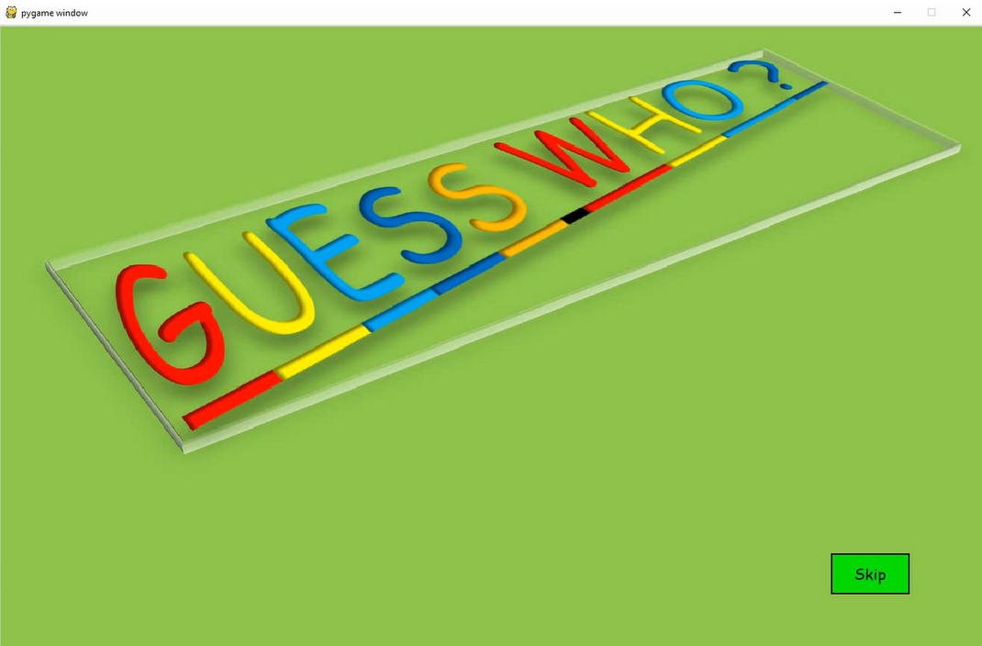

The starting cover page which displays the name of the game.Click ‘Skip’.

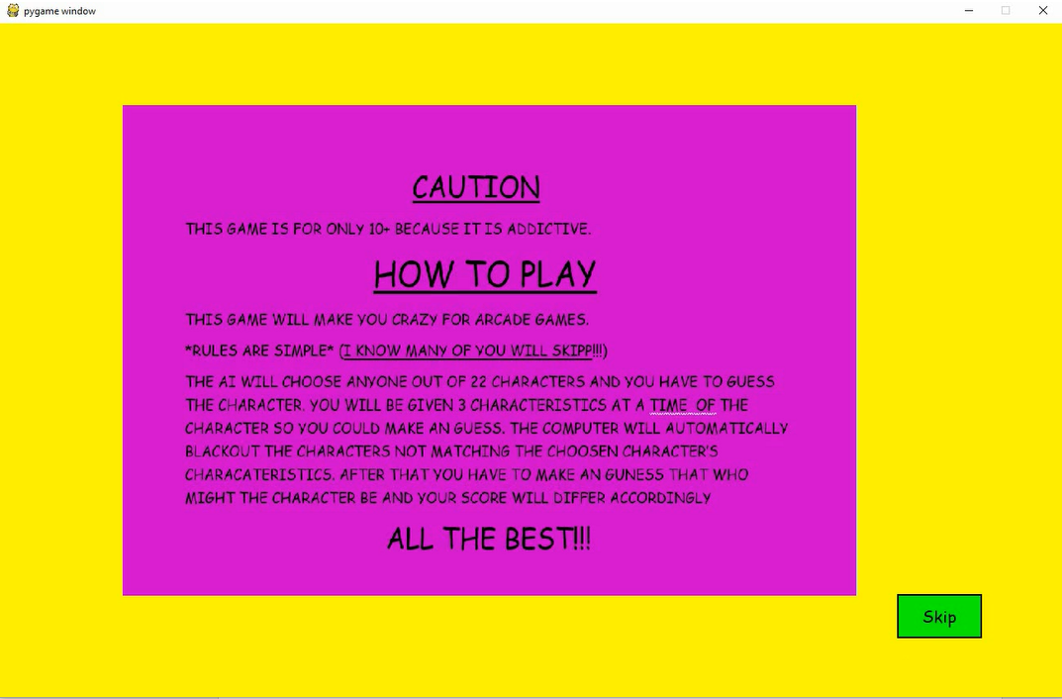

“How to Play” page.Click ‘Skip’.

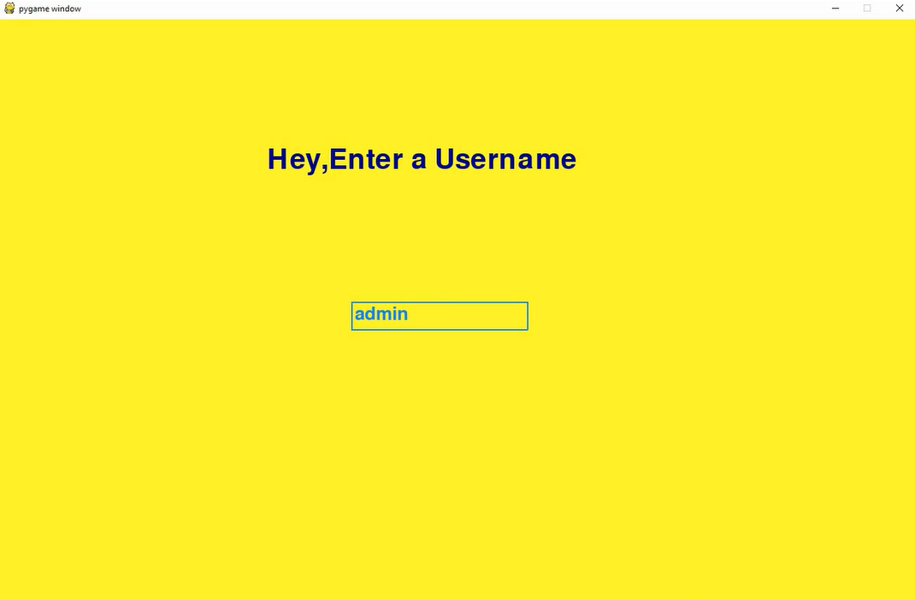

Write your username and press ‘Enter’.

If new username,

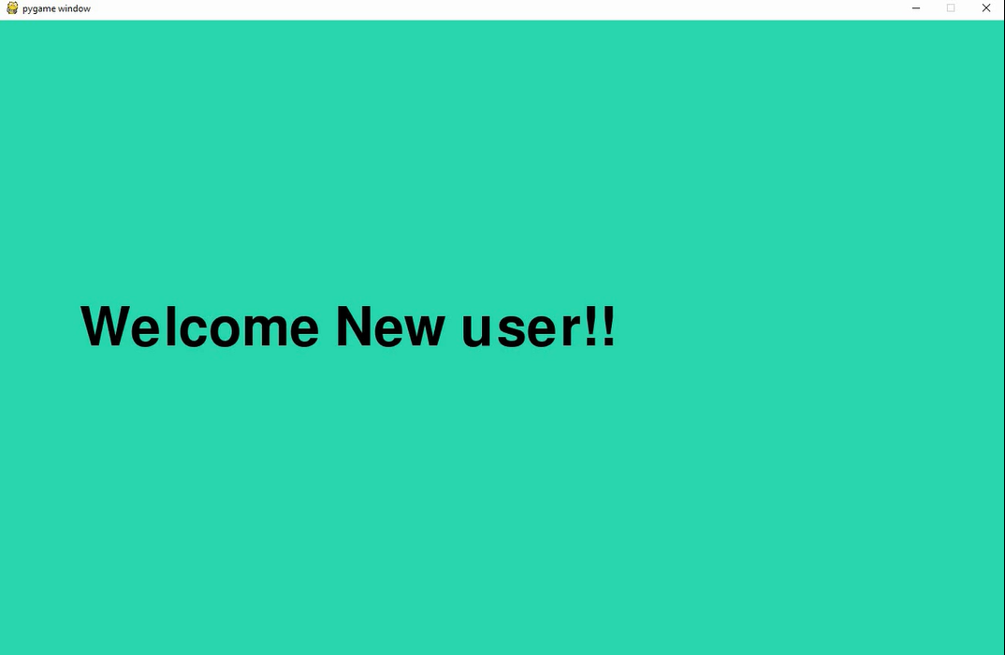

If username already registered,

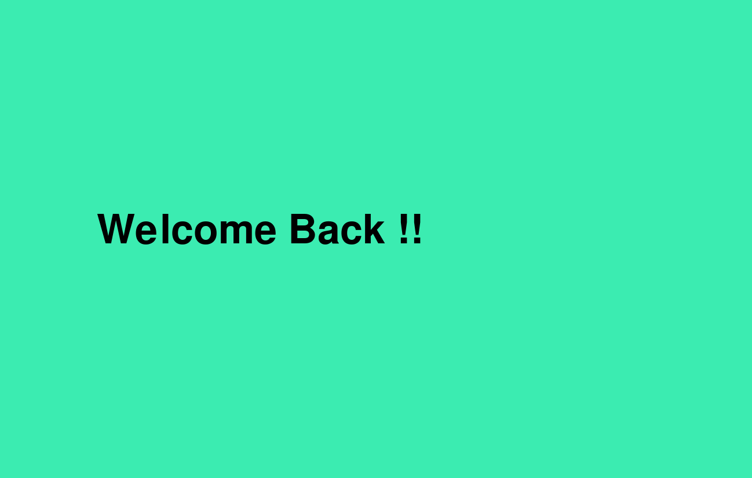

After few seconds,

Page giving a example of the game and greeting the player. Press ‘Start’

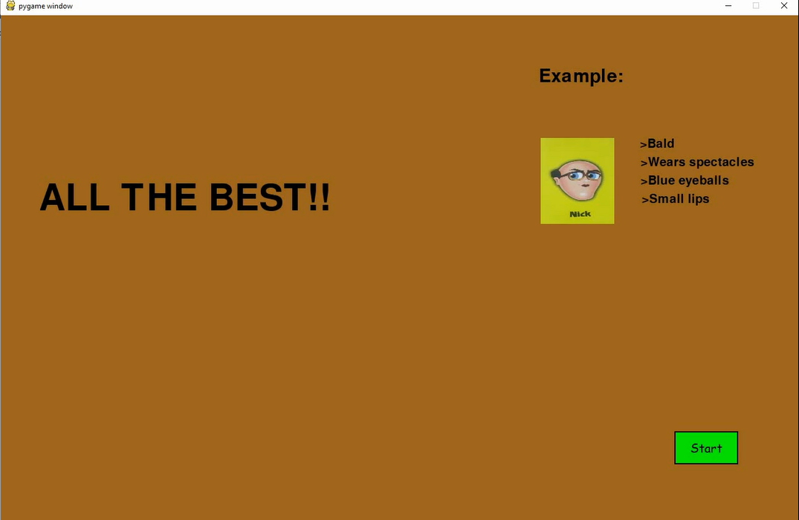

The main interface of the game. You can press any one of the three green buttons.

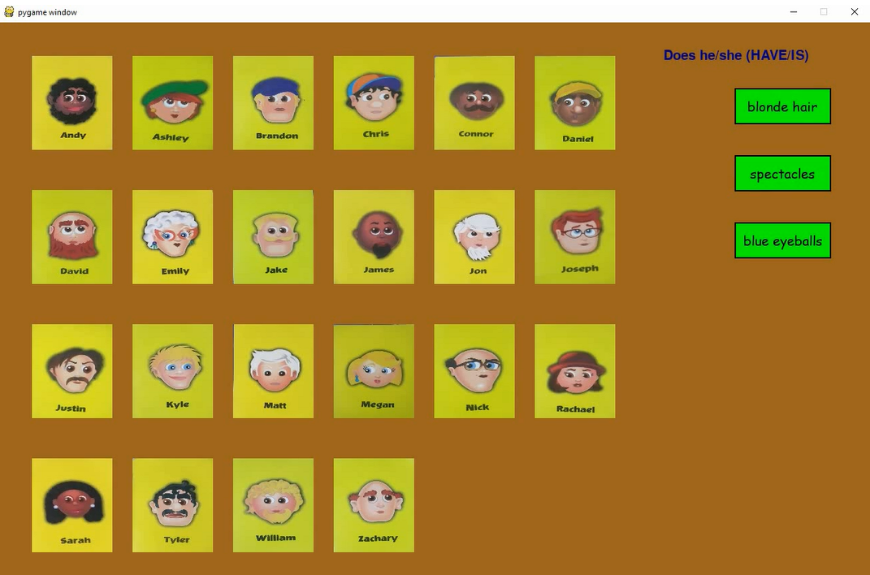

Option 1: Selected the ‘blonde hair’ option and it says that the character it has chosen doesn’t have blonde hair, so automatically all the characters with blonde hair are crossed.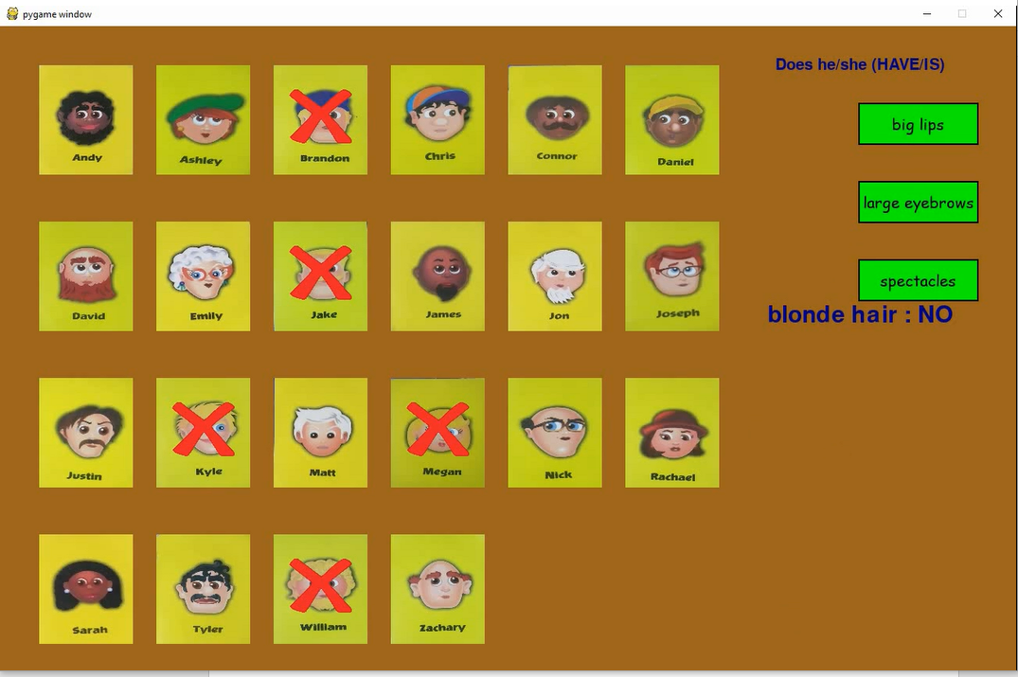

Option 2:Now, selected the ‘big lips’ option and it says no.

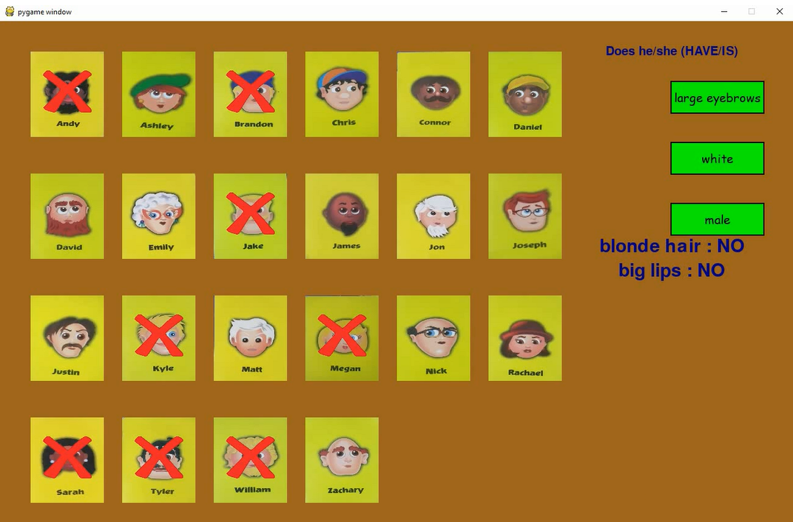

Option 3: Now, selected ‘male’ option and it says yes, so all females are crossed.

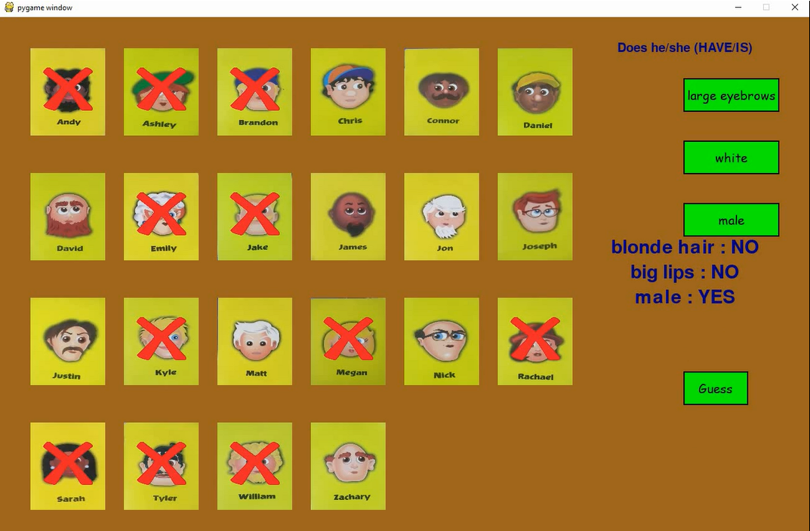

Now press the ‘Guess’ button to make an guess out of the characters left.

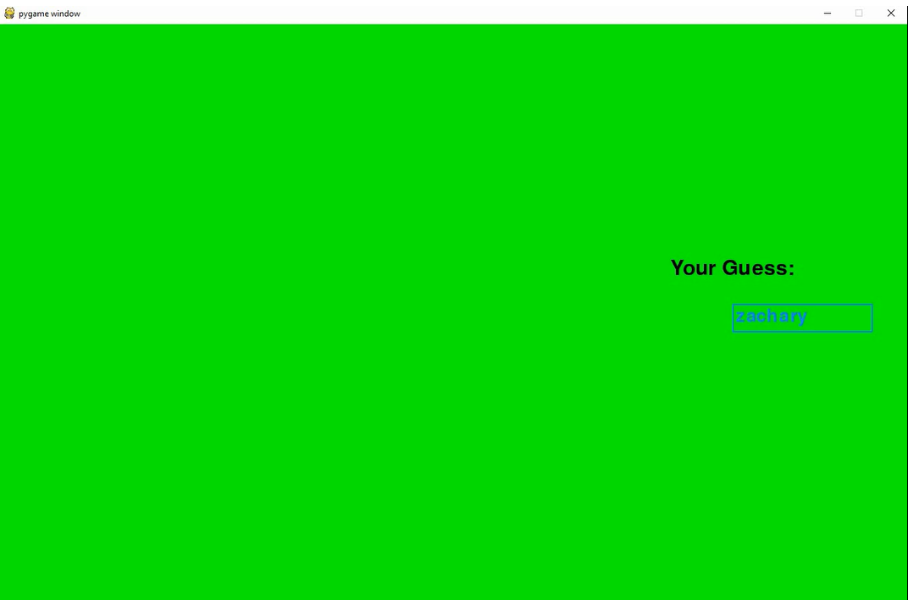

Write any name from the remaining characters in lower case. Press ‘Enter’.

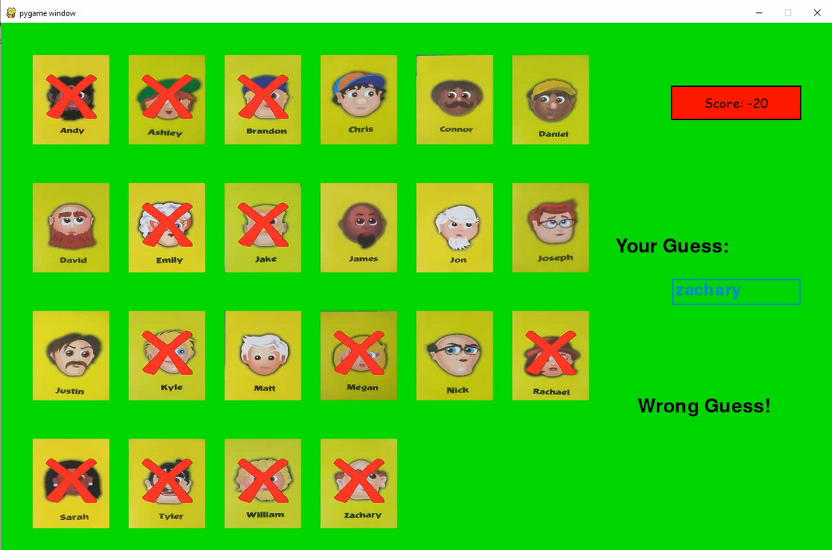

So, we entered ‘zachary’ and it said ‘Wrong Guess!’, so ‘zachary’ was crossed and your score(starts from 0 if new user) decreases by 20.

Guess 2

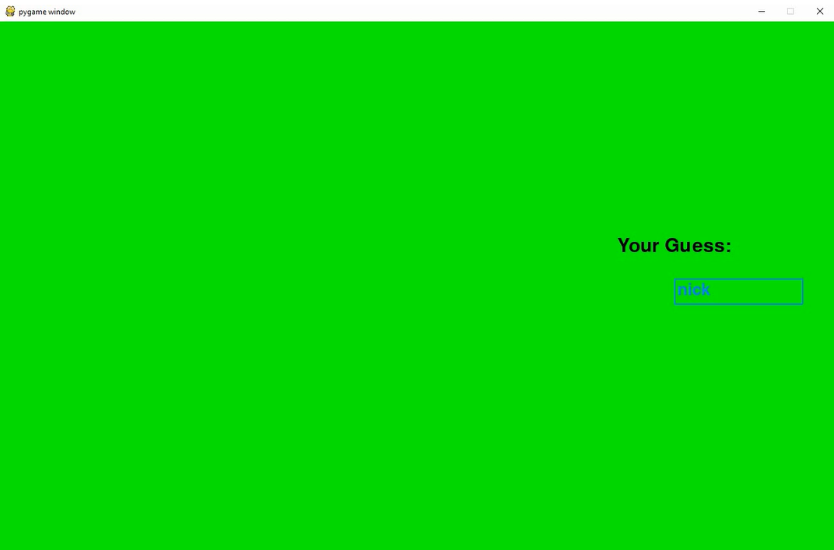

Now we guessed ‘nick’. Press ‘Enter’

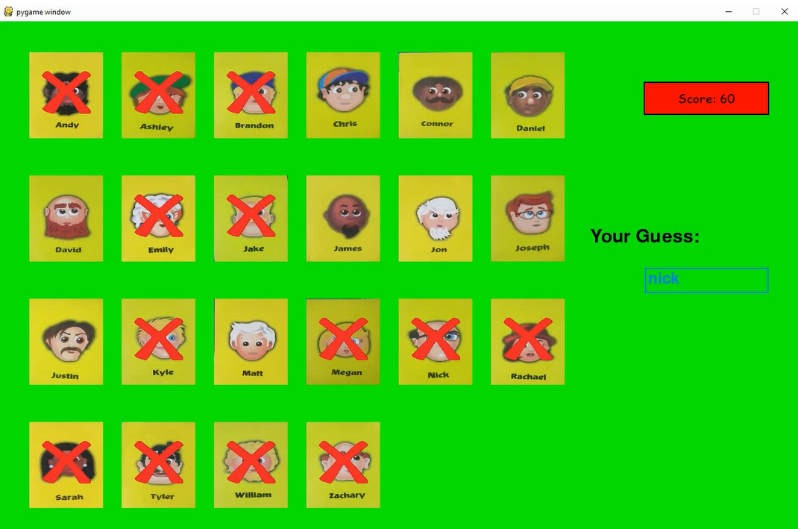

It didn’t came ‘Wrong Guess!’ so something is fishy??

Let’s find out

Leaderboard

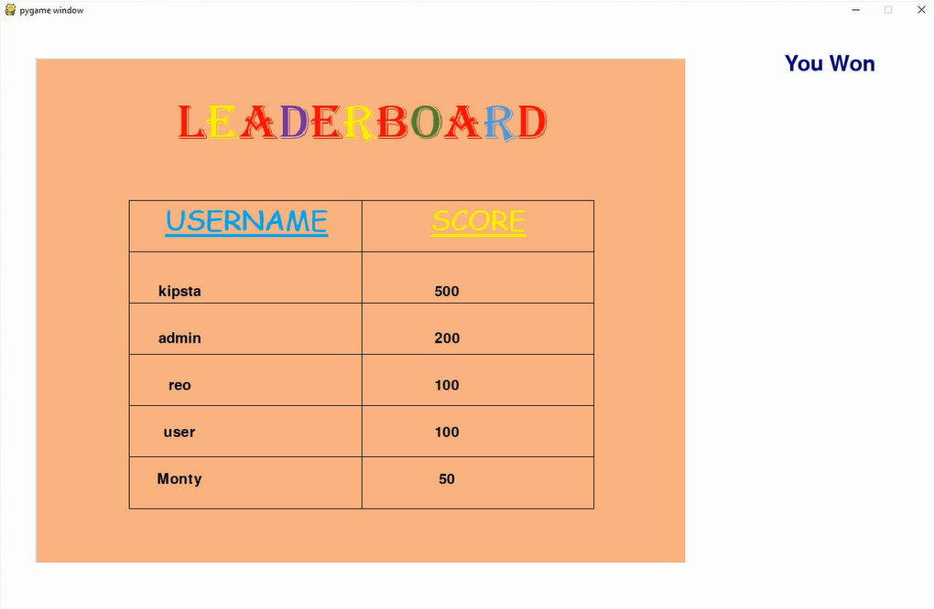

This is the leaderboard which shows the top 5 usernames according to their scores. And on the upper right corner you can see “You Won”, means our guess was correct.

When you guess correct in less than the ((number of characters left) – 1) then your score gets increased by 100 points.

On this page,you have the option to chose whether you want to save your username or not.

If you press “Yes”, the username will be saved and your score will be updated.

If you press “No”, the username will be deleted from the database.

After you press any of the button,

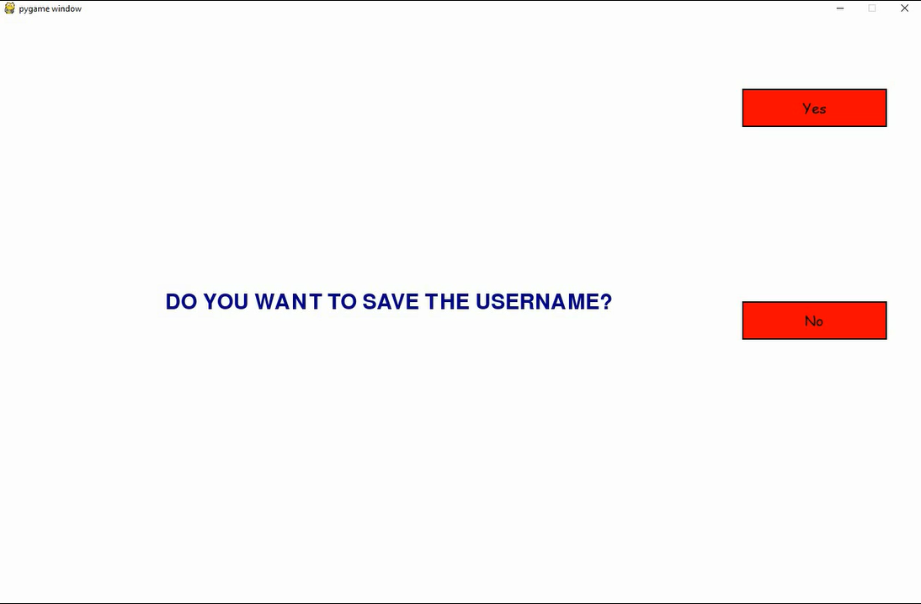

Here, you have the choice to again play the game or exit, so you don’t have to restart the program again and again.

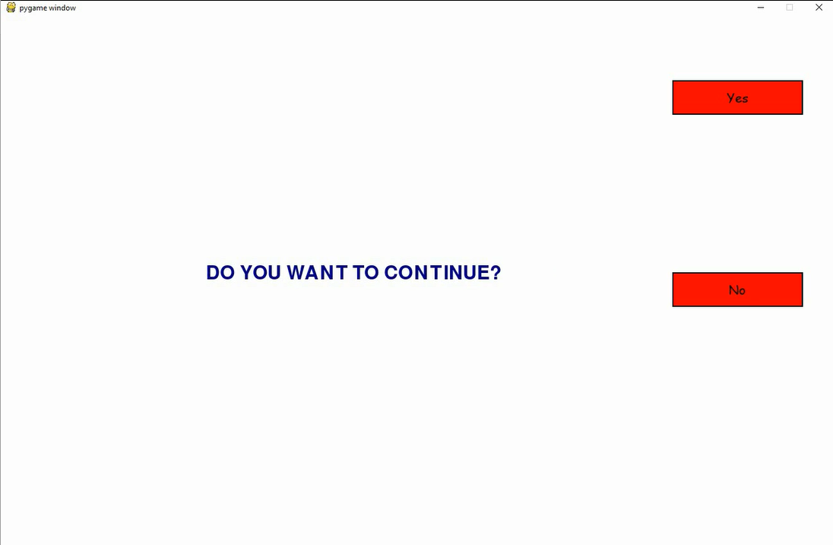

THANK YOU